Strategy of Sustainable Development as a Road Map of Civilization

Andrii Petrov, Ivan Kulenko, Anna Levka
Perto Mohyla Black Sea National University, Mykolaiv, Ukraine,
e-mail: andrii.petrov@gmail.com

Abstract text Abstract text Abstract text Abstract text Abstract text Abstract text [1, 2]. Abstract text Abstract text Abstract text Abstract text Abstract text Abstract text Abstract text Abstract text Abstract text Abstract text Abstract text Abstract text [3]. Abstract text Abstract text (Figure). Abstract text Abstract text Abstract text Abstract text Abstract text Abstract text Abstract text Abstract text Abstract text Abstract text Abstract text Abstract text Abstract text Abstract text Abstract text Abstract text Abstract text Abstract text Abstract text Abstract text Abstract text Abstract text Abstract text Abstract text Abstract text Abstract text Abstract text Abstract text Abstract text Abstract text Abstract text Abstract text Abstract text Abstract text Abstract text Abstract text Abstract text Abstract text Abstract text Abstract text Abstract text Abstract text Abstract text Abstract text Abstract text Abstract text Abstract text Abstract text Abstract text Abstract text Abstract text Abstract text Abstract text Abstract text Abstract text.

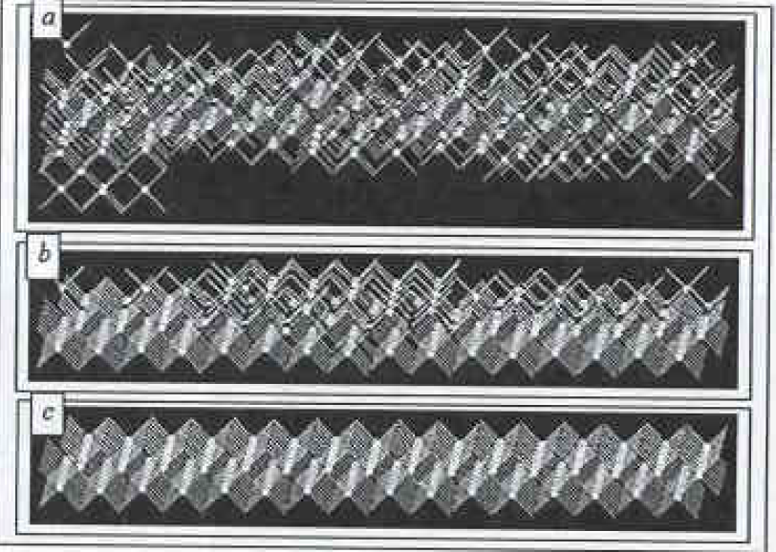
Fig. An operation example of the new model: ɑ – rough surface (001); b – surface ɑ after the partial polishing; c–perfect surface (001) after the finishing polishing of the surface ɑ
References
- M. Kolmer et. al. Appl. Surf. Sci.(2014) 288:83
- M.A. Gosalvez et.al. J. Micreomech. Microeng (2008) 18:1
- A.V. Yukhnevich, I.A. Mayer, A.E. Usenka Appl. Mech. (2013) 28:123

